**Experiment 10:** Create a Cloning of a VM and Test it by loading the Previous Version/Cloned VM.

Step 1: Creating New File.

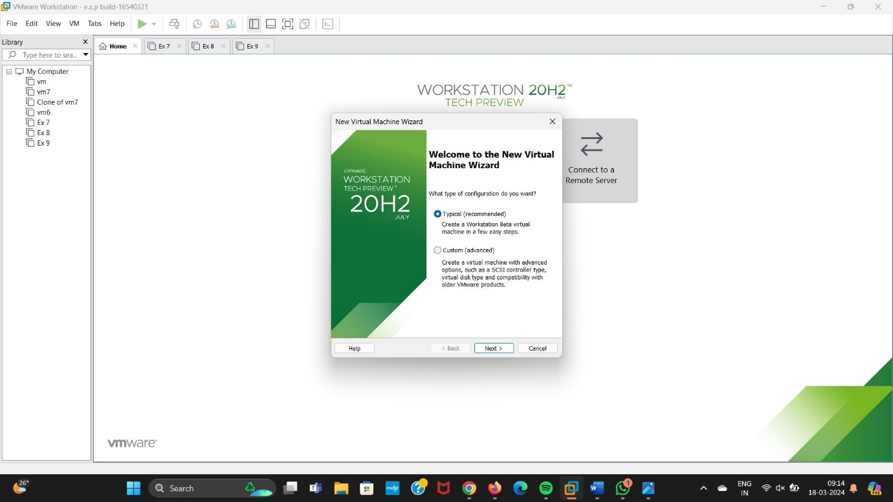

Step 2: Click on I will install the Operating System later.

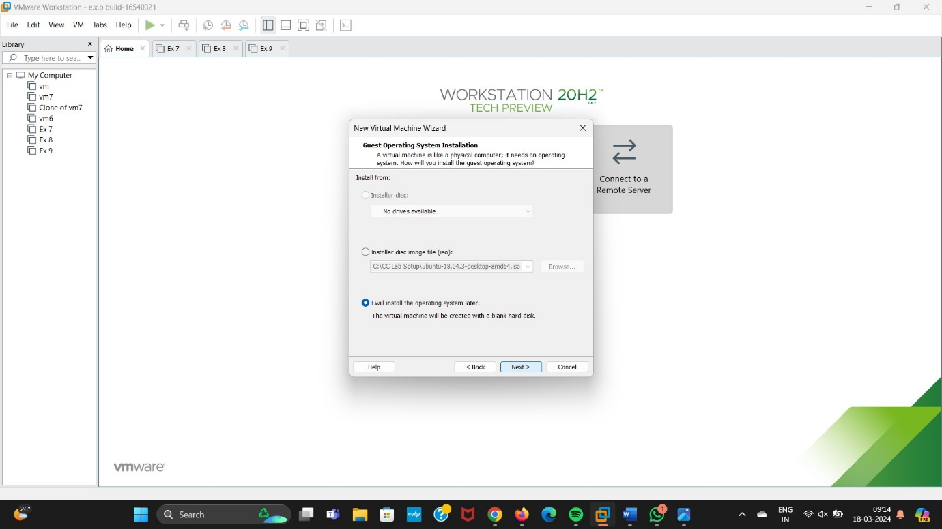

Step 3: Select any operating system.

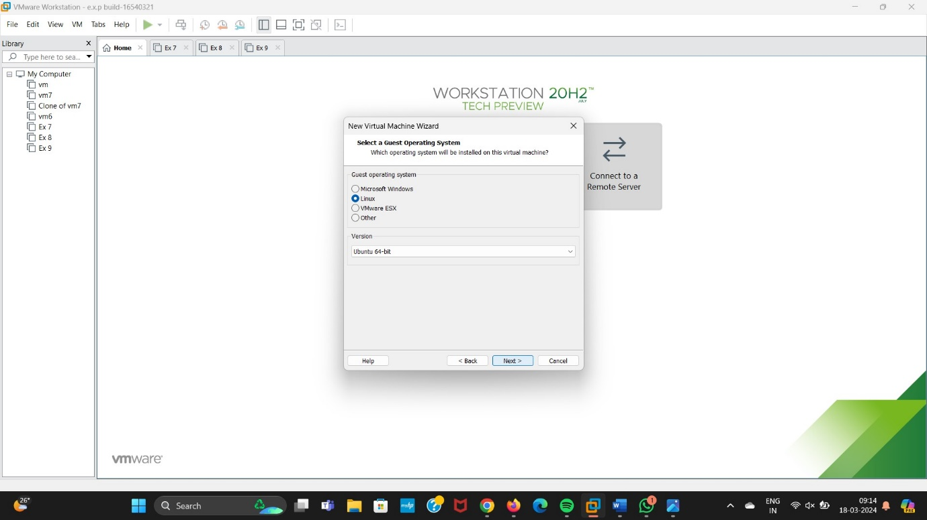

Step 4: Give a Name for Virtual Machine.

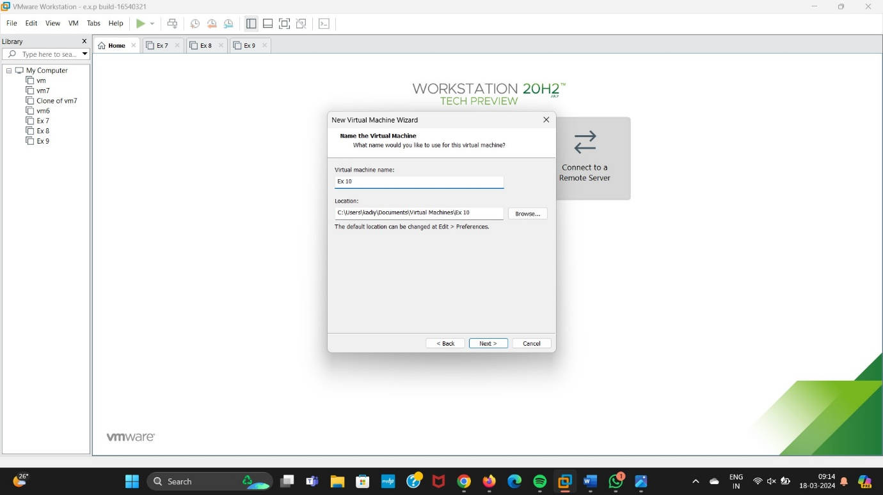

Step 5: Click on Finish Button.

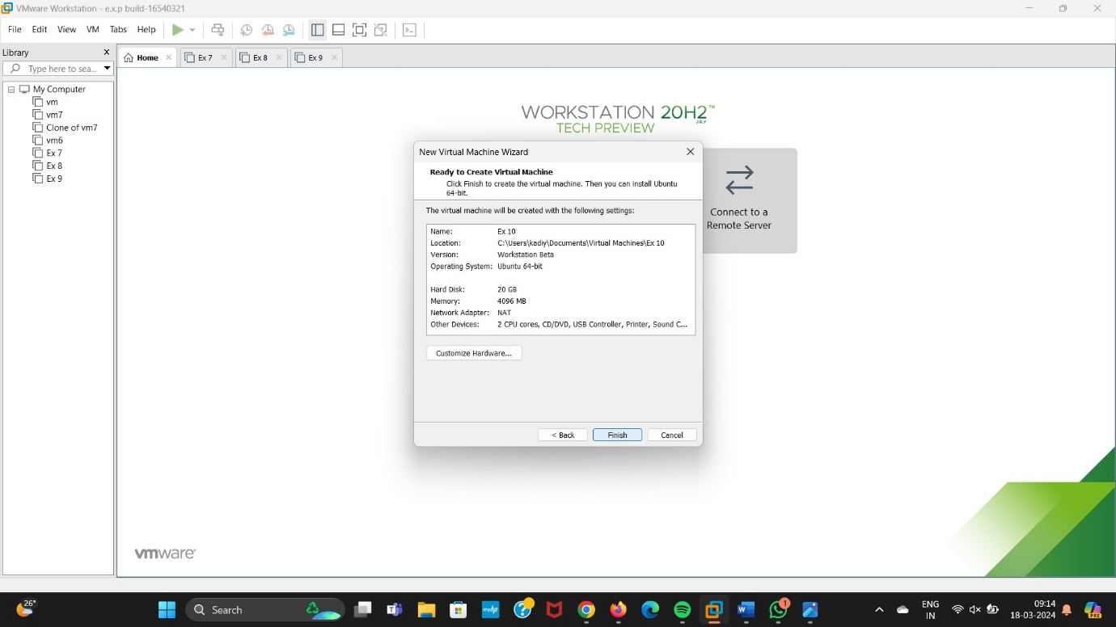

Step 6: Select VM from the Toolbar.

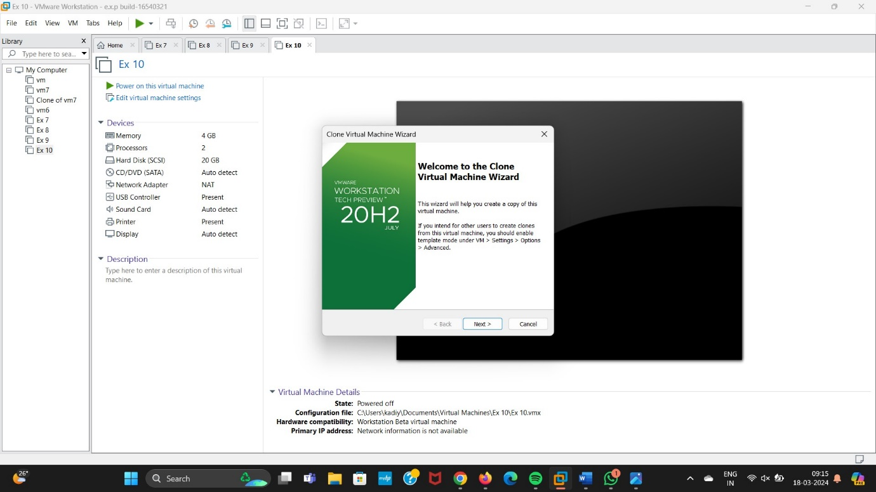

Step 7: Click on Next by selecting The current Tool is the Virtual Machine.

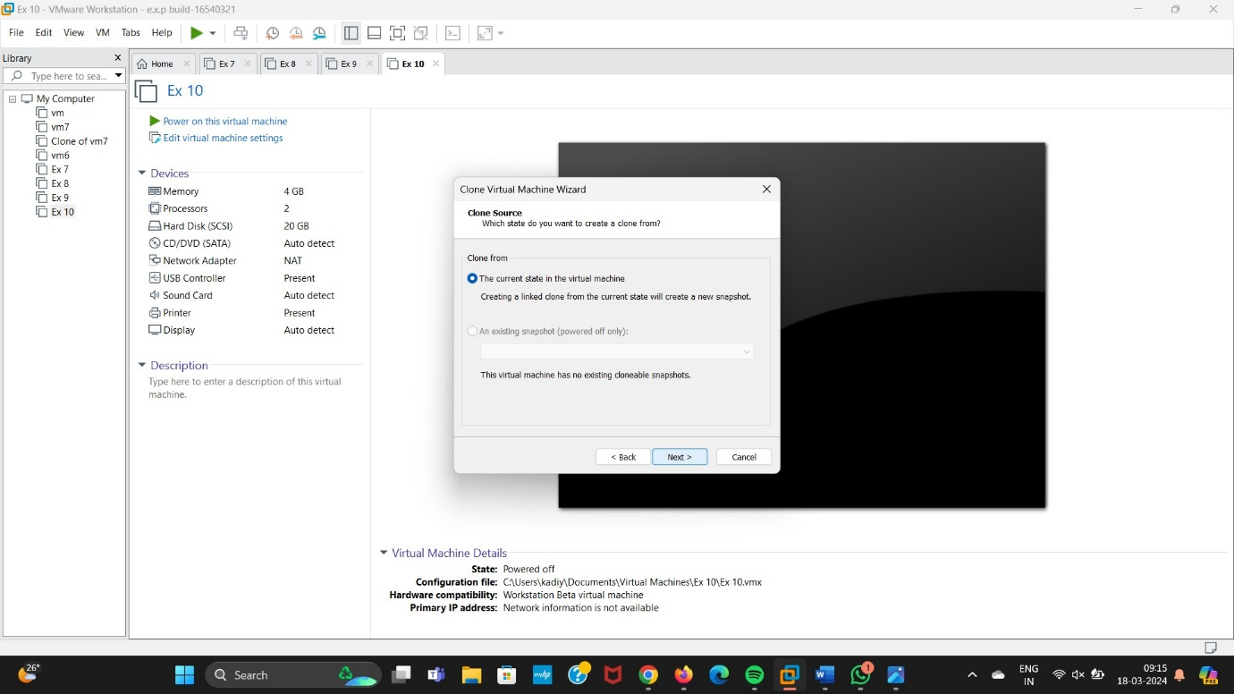

Step 8: Select on Create a Full Clone Option.

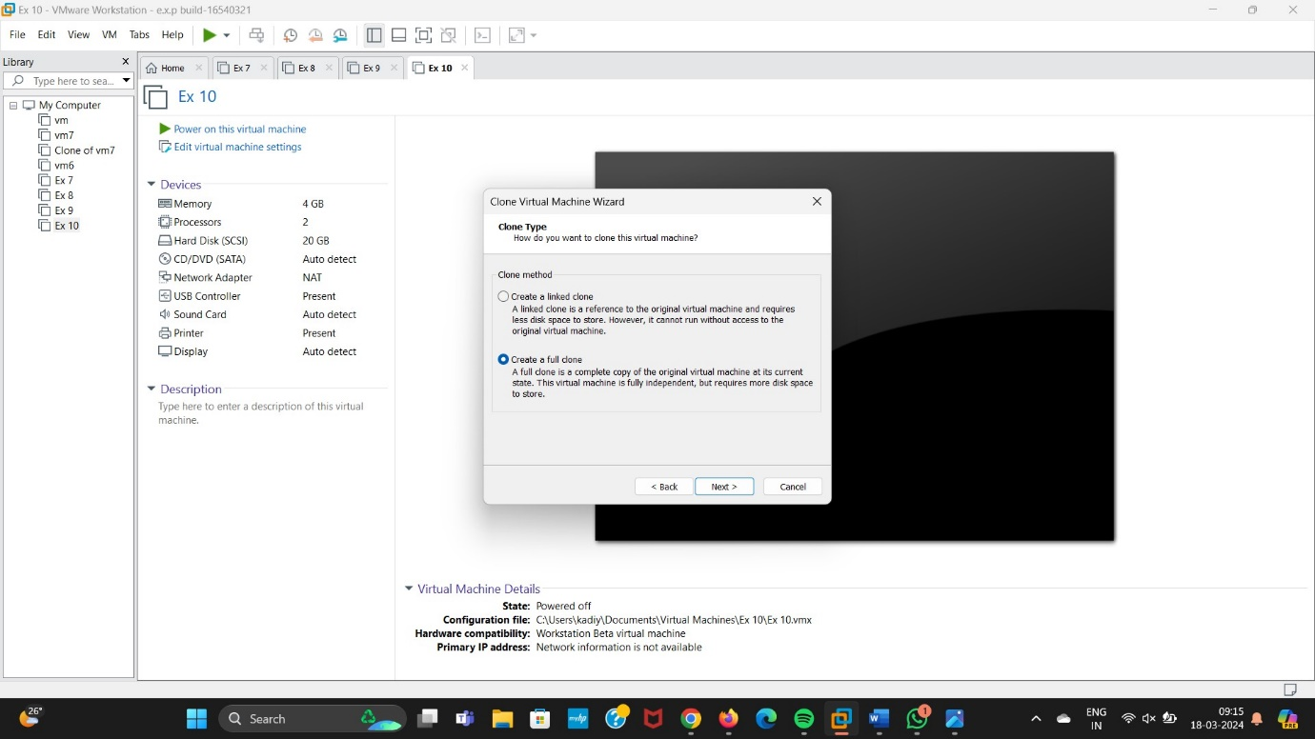

Step 9: Give a Name For Virtual Machine.

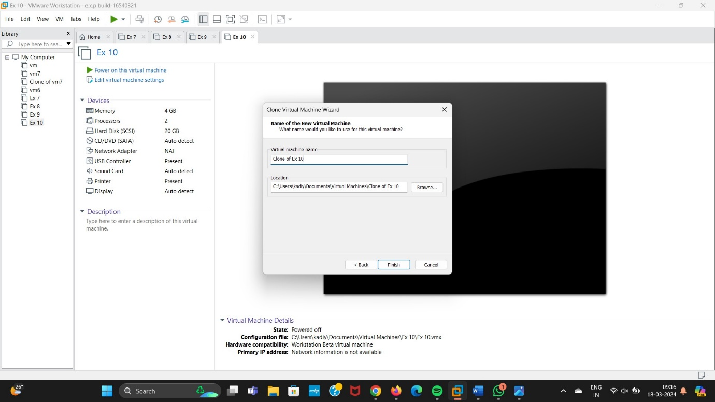

Step 10: Here the Clone output is created.

